**TOP TIME OPEN HOUSE**

**At Beccles Library**

***Thursday 10th August***

***2.00 – 3.00pm.***

***Quiz Time!***

***On the second Thursday of each month***

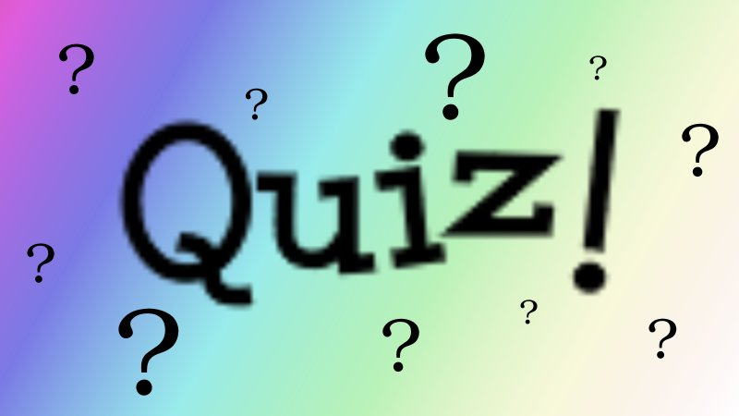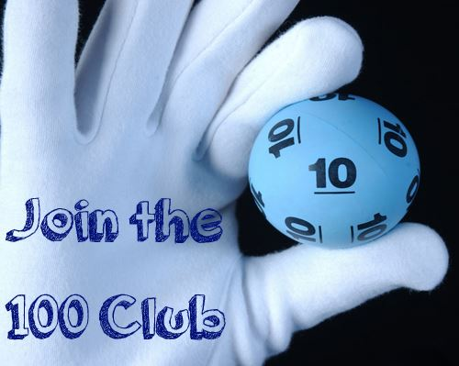

*Do you enjoy a challenge?*

*Come along and take part in our new afternoon quiz.*

*Questions to include multiple choice, a picture round and ten answers which begin with N!*

*(You do not need to be in a team – this is a quiz for individuals*.)

-----------------------------------------------------------------------------

*We will also be drawing the winners of the* ***Beccles Library 100 Club.******Prizes of £25 and £15 every month.***

*For just £1 per month you are supporting your local Library!*

*Please ask for a form to join.*